Submitting an application for CE Approval

- Applications must be submitted at least 7 days prior to the event date.
- A $100 late fee is applied if the application is submitted less than 30 days prior to start of course.
- Refunds are not authorized for rejected applications!
- Vendors must contact CAMPEP before submission of an application.
- All programs with 10 or fewer speakers: A CAMPEP Bios is required for all speakers.
- An updated CAMPEP bio is required for all Program Directors.
- Note: CAMPEP reviewers may ask for Bios as deemed necessary.
- Merge the Bio documents into one file and upload as supporting documents.
- An application is not considered submitted until the appropriate fee is accepted by the online application system.

- Click on the left menu titled “Submit an Application” and the following screen will appear.

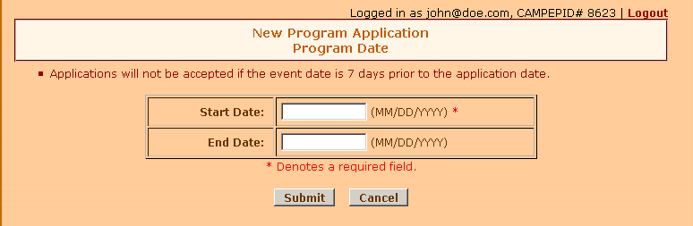

- Enter the program start date (required).
- If any, enter the program end date (not required).
- Click on the Submit button and the following screen will appear.

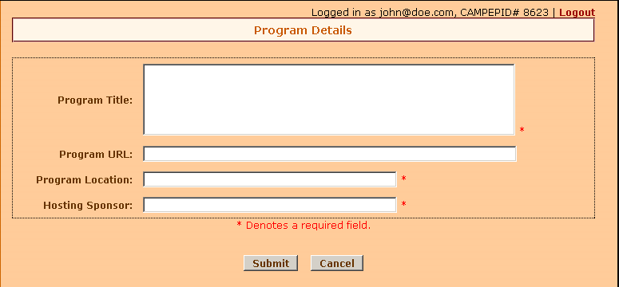

- On the Program Details page, complete the following fields:
  - Enter the program title (required).
  - Enter Program URL (not required).
  - Enter Program Location (required).
  - Enter Hosting Sponsor (required) and click on the Submit button and the following screen will appear.
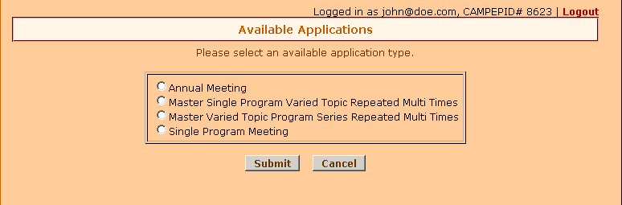

- On the Available Applications page, select an application type and click on the Submit button and the following screen will appear. New application options may appear online.

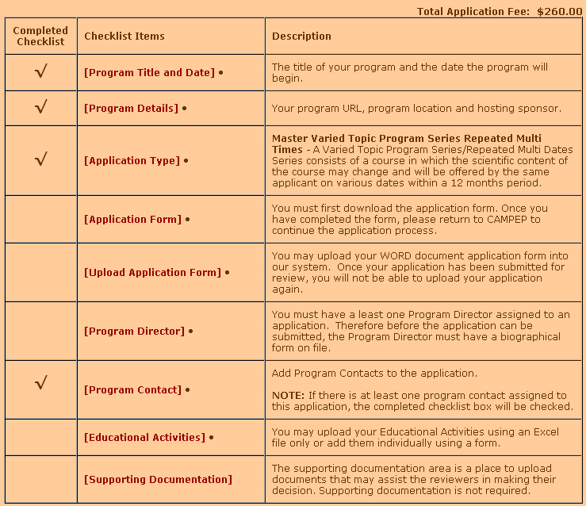

- Continue Application Process page:
  - You will have the ability to edit the Program Title and Program date.

  - Click on the [click here] link located at the top of the page and the following screen will appear.

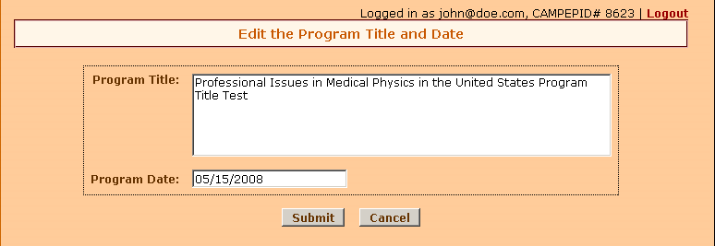

  - Edit the Program Title and Program Date and click on the Submit button.
  - A $100 late fee will be charged if the application date is less than 30 days from the program date.

  - Below is a screenshot of your application. As you complete each checklist item, the Completed Checklist column will be checked off.

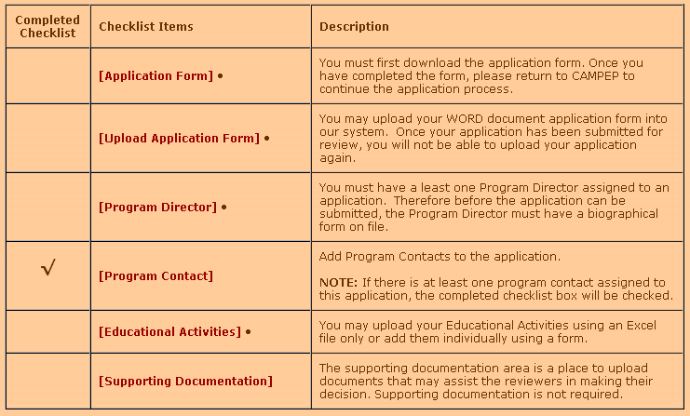
  - Now you notice that the completed checklist column beside the [Program Contact] is checked because the system automatically adds you as a Program Contact when creating a new application.

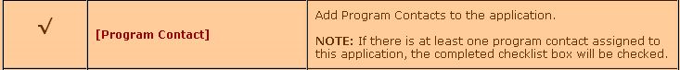

    - If you would like to add additional Program Contacts, click on the [Program Contact] link and the following screen will appear.

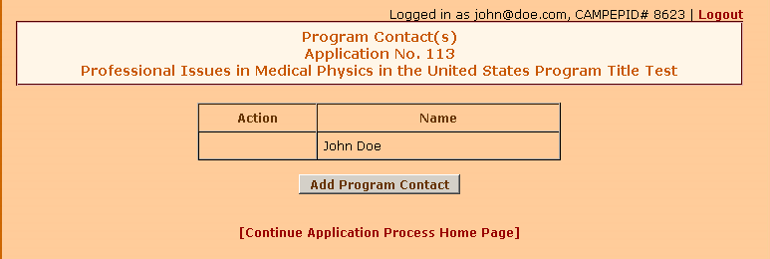

    - As previously discussed, the system automatically added you as a Program Contact. To add a new Program Contact, click on the Add Program Contact button and the following screen will appear.

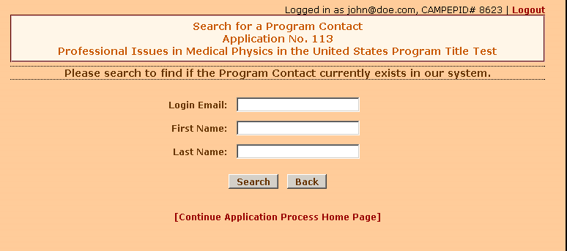

    - You may enter in the contact Login Email, First Name or Last Name to search the database. If users are found, the following message will appear on the screen.
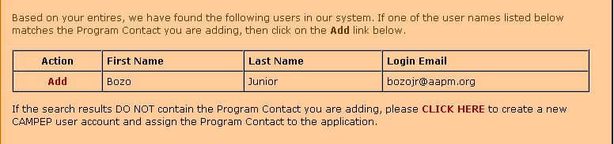

    - If this is the user you would like to add as a Program Contact, click on the Add link and the following screen will appear.

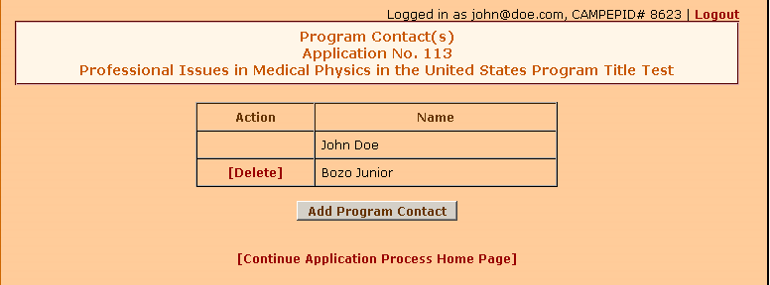

    - An email will be submitted to Bozo Junior to inform him that he has been added as a Program Contact to your application.
    - If the search results do not contain the Program Contact you are adding, then click on the CLICK HERE link to create a new CAMPEP user account and assign the user as a Program Contact. The following screen will appear.

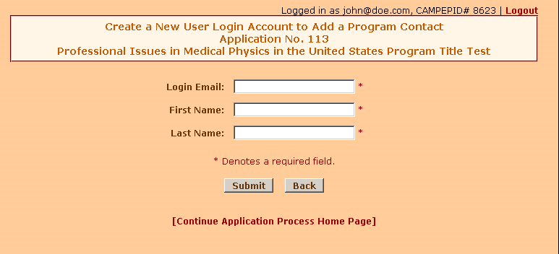

    - Fill in the form fields and click on the Submit button and the following screen will appear. The new user is added below as a Program Contact.

    - An email will be automatically sent to the person you are adding as a program contact to make them aware that they have been added to your application. For new users, they must validate their email address in order to access the system.

  - Click on the [Application Form] link to download your application form, which is based on the application type you selected on the Available Applications page.

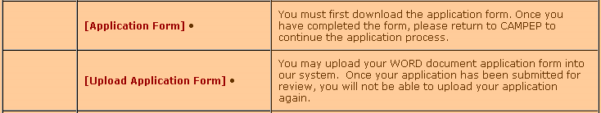

  - Please complete it in its entirety.
  - Go back to the Continue Application Process page and click on the [Upload Application Form] link and the following page will appear.

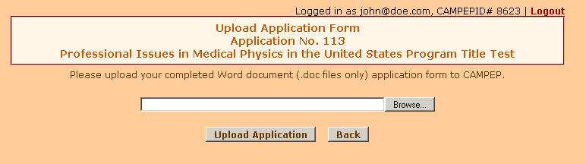

  - Click on the Browse button to locate your completed application form on your computer and click on the Upload Application button and the following window will appear.

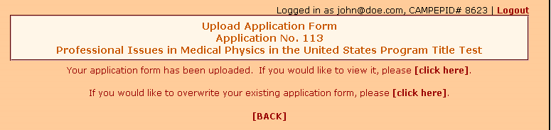

  - Please note that once you have uploaded your application, you will not be able to remove it. However, you will be able to overwrite it as needed. When you have completed uploading your application form, please click on the [Back] link to return back to the application process page.
  - Now you should notice that the completed checklist column has a check mark next to the [Application Form] and [Upload Application Form]. See screenshot below.

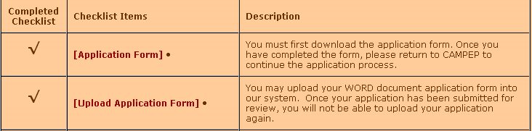

Program Director: You must have at least one program director on file per application. The program director must have a current CAMPEP biographical form on file.

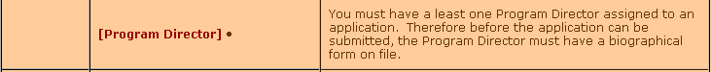

  - To add a program director, click on the [Program Director] link shown above, and the following screen will appear.
    - For RDCE applications, please list all committee members under program directors. All committee members listed here must have a BIO on file.

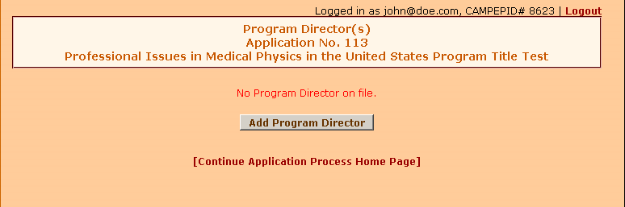

    - By default, no program directors are listed on file. To add a Program Director, click on the Add Program Director button and the following screen will appear.

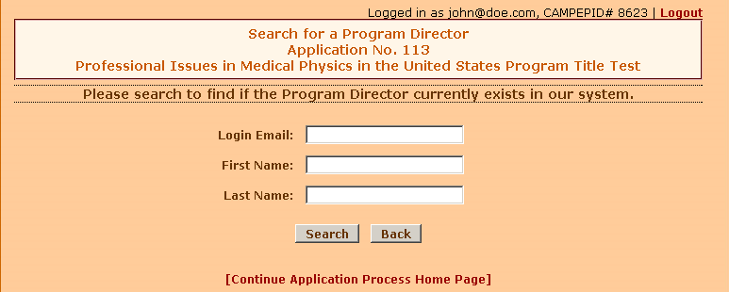

    - You may enter in the director’s Login Email, First Name or Last Name to search the database. If users are found, the following message will appear on the screen.

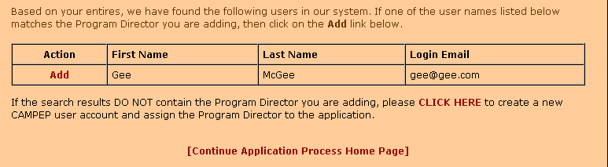

    - If this is the user you would like to add as a Program Director, click on the Add link and the following screen will appear.

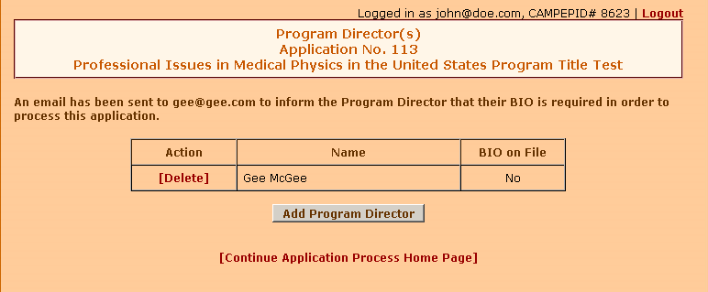

    - In this case, Gee McGee has been added as the Program Director.
    - An email will be automatically sent to the person you are adding as a program director to make them aware that they have been added to your application. For new users, they must validate their email address in order to access the system.
    - For Program Directors with no BIO on file, an email will be sent informing them that their BIO is required in order to submit the application. During the application process, if there is a Program Director that does not have a BIO on file, you will not be able to submit your application and a “Pending Bio” message will appear in the completed checklist column. See screenshot below.

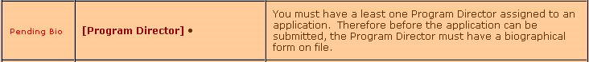

    - If the search results do not contain the Program Director you are adding, then click on the CLICK HERE link to create a new CAMPEP user account and assign the user as a Program Director. The following screen will appear.

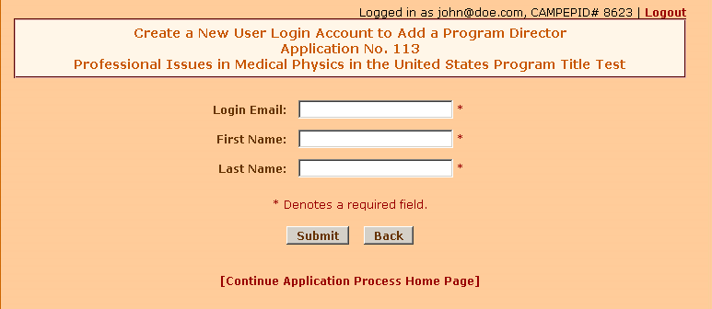

    - Fill in the form fields shown above and click on the Submit button and the following screen will appear. The new user is added below as a Program Director.

    - All users that you have added to the application as a program director only will have access to view the application. Only the Applicant (yourself) will have all access privileges to the application. If the application is in review, the Applicant will have access to view the application only.

    - If all BIOs are on file, then the Program Director item will be check. See screenshot below.

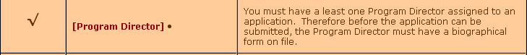

  - Educational Activities: You must have at least one Educational Activity on file in order to process your application.

    - To add educational activities, please click on the [Educational Activities] link and the following screen will appear.

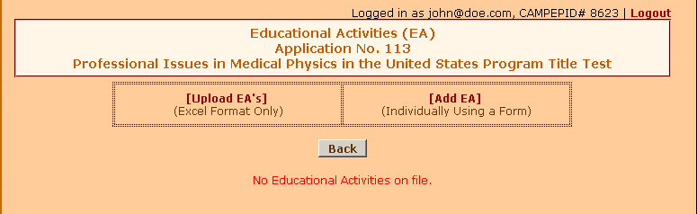

    - To upload your EA’s, click on the [Upload EA’s] (Excel Format Only .xls) link and the following screen will appear.

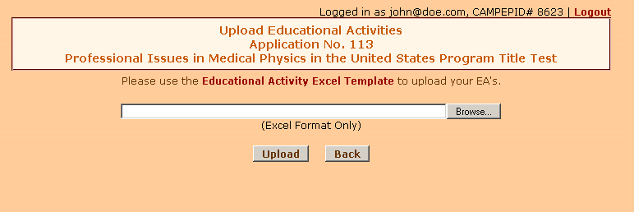

    - Click on the link above the form titled “Educational Activity Excel Template” to be used to upload your EA’s. You must use this form.
    - Follow the instructions within the Excel file.
    - After you have completed the Excel file to upload your EA’s, click on the Browse button to locate your file on your computer and click on the Upload button. Please DO NOT click on the Upload button more than once, as this may produce numerous duplication errors. Duplicate EA’s are prohibited.
      - During the process of uploading your EA’s, you will be able to address any errors produced by the upload. The new system will inform you of the exact location of the error within your file. You will no longer need assistance from CAMPEP Admin when uploading your EA’s.
    - When your upload is complete, the following message will appear on your screen.

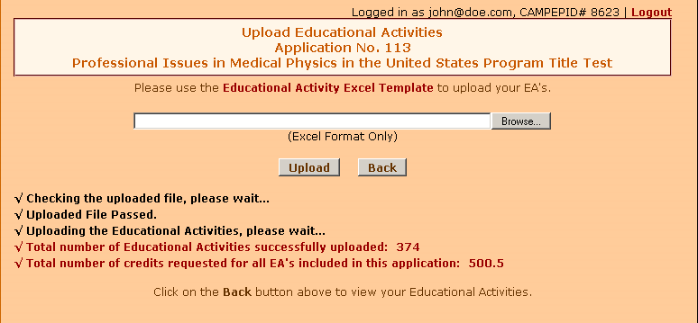

    - Click on the Back button to view your Educational Activities.

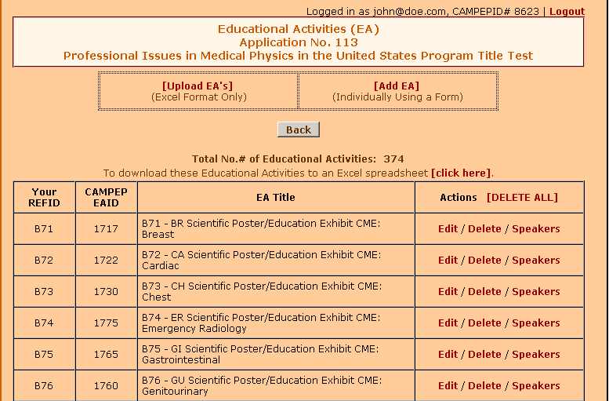
    - You may also add the EA’s individually using a form. Just click on the [Add EA] link and the following screen will appear.

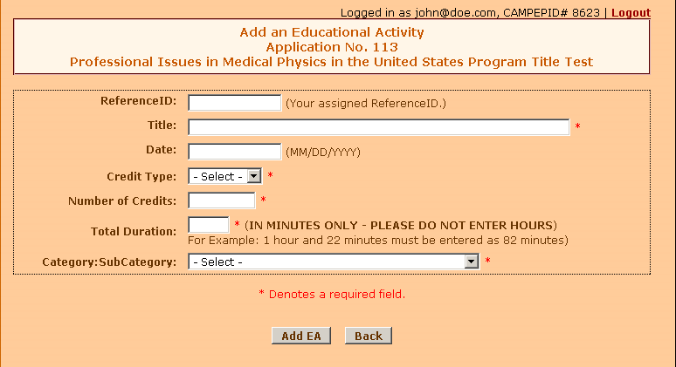

    - Complete the form above and click on the Add EA button and the following message will appear on your screen.



    - Click on the Back button to view your Educational Activity.
  - Once you have added/uploaded your educational activities, the EA’s will now be displayed on the main Educational Activities home page.
  - You have the option to Edit an existing EA, Delete an EA, and add Speakers to an EA.
  - If you have faculty/speakers to add to the EA, click on the link titled Speakers next to the EA you would like to add the speaker to under the Actions column above and the following screen will appear.
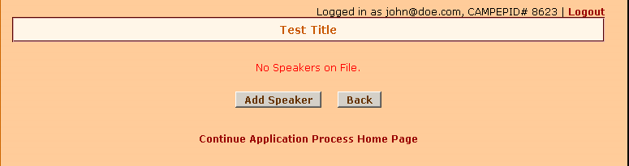
    - Click on the Add Speaker button to add a speaker to the EA selected.
    - Once you have added the speakers to the program application, the following will appear on the application.

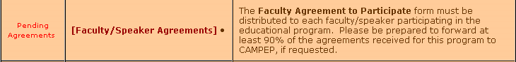
    - Click on the [Faculty/Speaker Agreements] link and the following page will appear.
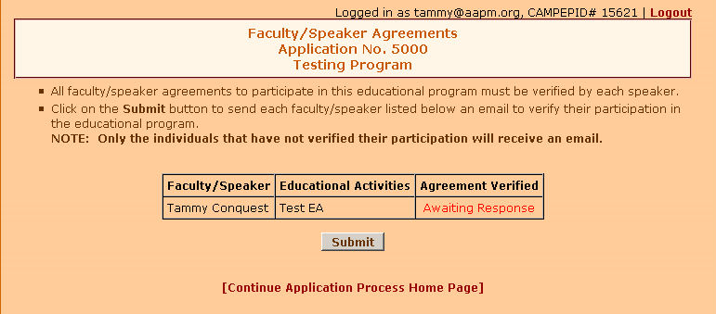
    - Click on the Submit button to send an email to each faculty/speaker listed so that they can verify their participation in the program educational activity.
    - The faculty/speaker must complete the following during the application process.
      - Each faculty/speaker must complete a Faculty Agreement.
      - The faculty/speaker will be notified via email.
      - The email to the faculty/speaker will include instructions on how-to verify their participation in the educational program.
      - There will be a link within the email that will redirect the speaker to the appropriate page to verify the participation.
    - If the speaker has not responded you will not be able to submit your application.
    - If the speaker answers NO, then you must remove the speaker from the EA and add a new speaker to the EA (which he or she must also verify their participation) in order to submit your application.

  - Supporting Documentation is a CAMPEP requirement for all Webinar and RDCE applications. (Refer to Program Requirements)

    - However, if you have additional documentation you would like to add to your application, please click on the link and the following screen will appear.

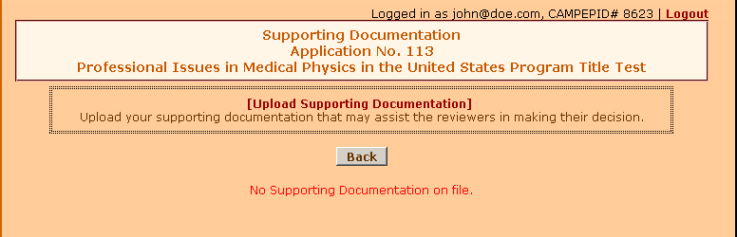

    - Click on the link titled [Upload Supporting Documentation] and the following screen will appear.
    - CAMPEP Bios are required for all programs with 10 or fewer speakers.
    - Merge the Bio documents into one file and upload as supporting documents.
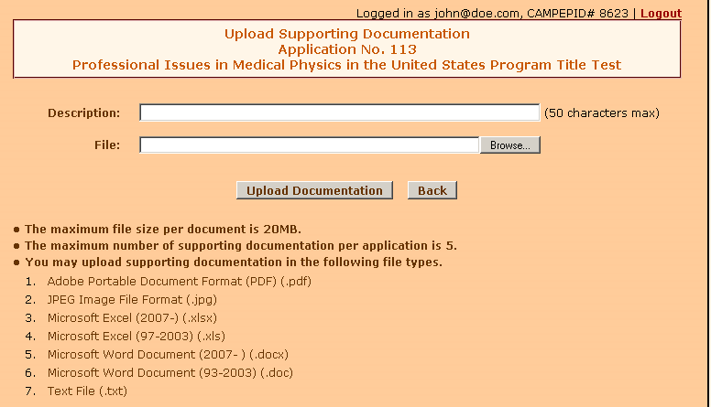

    - Type in the Description of the supporting document and click on the Browse button and the following screen will appear.

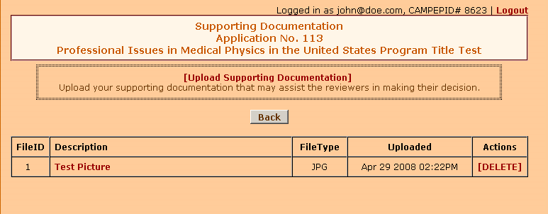

    - If you wish to upload more documents, just click on the [Upload Supporting Documentation] link again or click on the Back button to return to the Continue Application Process page.

  - The checklist items required to submit an application are as follows:
    - Application Form
    - Upload Application Form
    - Program Contact
    - Program Director w/BIO
    - Program Contact
    - Educational Activities
      - Speaker/Faculty assignment.

  - This is what your application should look like when completed.
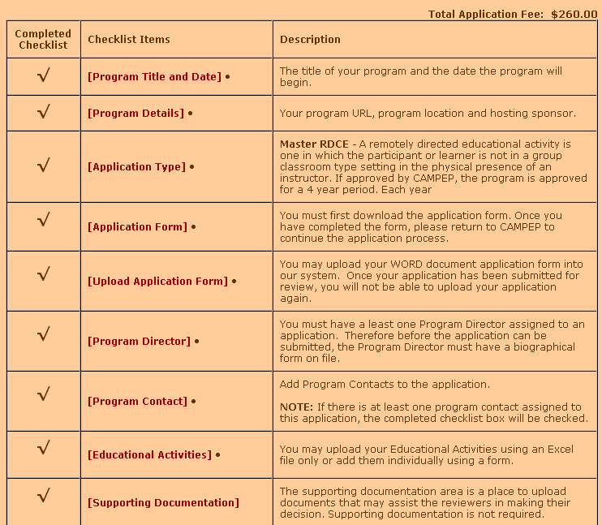

  - If all of the required items are completed, click on the “Submit Application” button and the following message will appear.

  - If you are sure you are ready to submit your application click [YES], otherwise click [NO].
  - If [YES], the next step is the payment processing.
  - Payment must be made online. Acceptable forms of payment are as follows:
Visa, Master Card and American Express.
  - Once paid, you will be redirected to “Continue Final Educational Program Application Process” page at which the Reviewers will be assigned. See screenshot below.

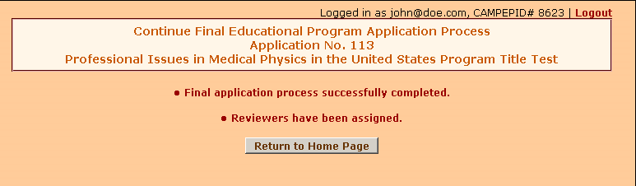

  - Click on the Return to Home Page button.
  - Once your application is in review, you will only have the ability to view it. Additionally, during the review process, you will have the ability to send an email as needed to the Reviewers.
  - To send an email to the Reviewer:
    - Click on the left menu titled “Program Applications”.
    - Click on the program title to access the application (view only).
    - Go to item #7 and click on the link titled [Email Reviewer].

    - If you would like to reply to a previous email submitted by a Reviewer, just click on the Subject title (which will be a link to the message) to access the email and click on the [Reply to Sender] link at the bottom of page.
- Also, on this page under item #9 titled Application Status Details, will give you the status of the application process. See screenshot below.

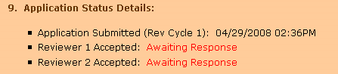

- Here’s a screenshot of an application that was rejected.

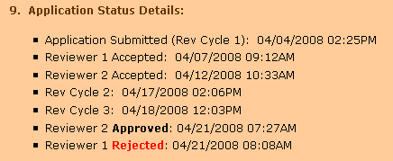

- Once your application has been approved by both Reviewers, you will receive an email from both Reviewers.
- To locate your application in CAMPEP after it has been approved:
  - Under the Applicant heading, click on the “Program Applications” menu and click on the [Approved Programs] tab.
  - PLEASE NOTE THAT YOU WILL HAVE THE ABILITY TO UPLOAD YOUR ATTENDEES ON OR AFTER THE PROGRAM HAS STARTED AND NOT BEFORE.

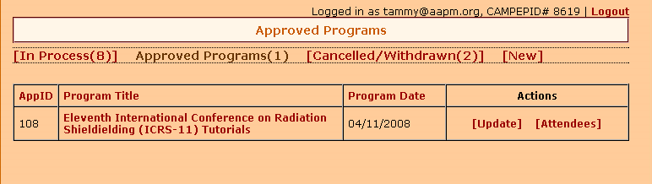

- Once the program has started, click on the [Attendees] link and the following screen will appear.

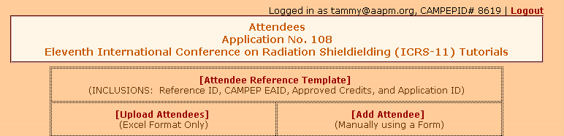

  - First, click on the link titled [Attendee Reference Template]. This spreadsheet will include your reference ID (if any), CAMPEP’s EAID, approved credits and the application ID. Therefore, all you would have to do is just fill-in the blanks.
  - Once you have completed the spreadsheet, you may upload the attendees. Click on the link titled [Upload Attendees] and the following screen will appear.

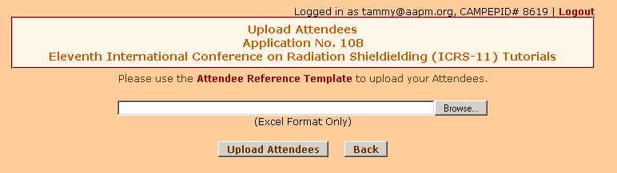

  - Click on the Browse button to locate your Excel file and click on the Upload Attendees button to upload your attendees.
  - If you would like to add the attendees manually using a form, click on the link titled [Add Attendee] and the following screen will appear.
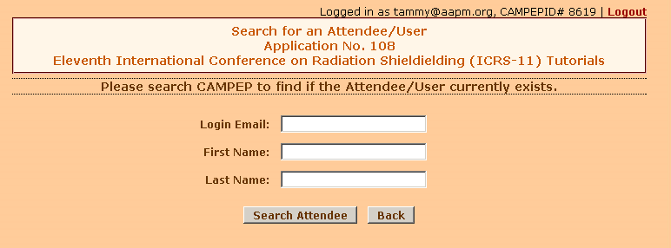

  - You may enter in the Attendee Login Email, First Name or Last Name to search the database. If users are found, the following message will appear at the bottom of your screen.

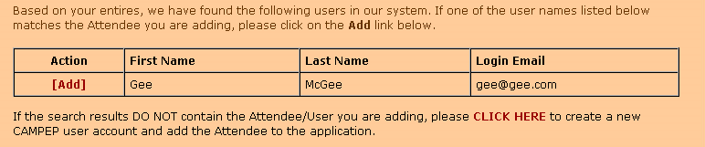

  - If the Attendee is found in the list below, click on the [Add] link and the following screen will appear.

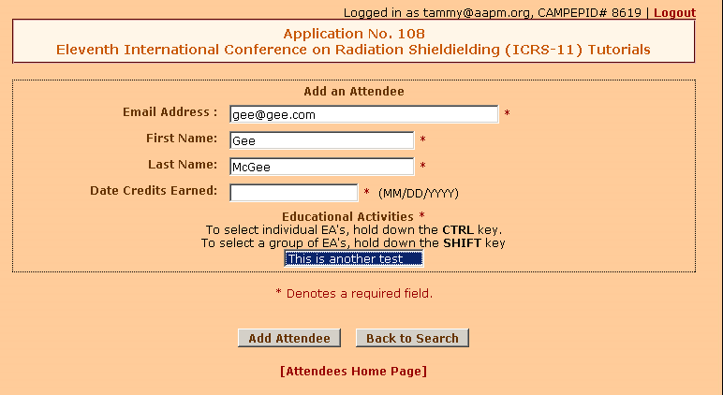
  - Enter the date credits were earned by the Attendee.
  - Select the EA. In this case, there is only one EA listed for this program. Therefore, to add the Attendee to the EA, just click on the EA to highlight it.
    - To select individual EA’s, hold down the CTRL key and click on each EA (to highlight it) you would like to add to the Attendee’s record.
    - To select a group of EA’s, hold down the SHIFT key to select the EA’s in groups.
  - Click on the Add Attendee button and the following screen will appear.

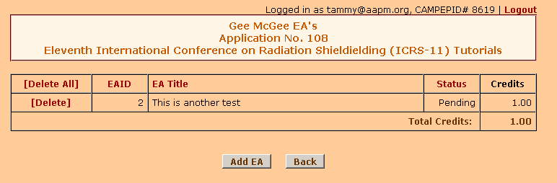

  - Notice that the credits for the Attendee is pending until the Applicant has made a payment to release the credits.
NOTE: JRC and CRC credits will have a status of Provisional until the Attendee releases them.
  - If you wish to add additional EA’s to the Attendee’s record, click on the Add EA button, otherwise click on the Back button and the following screen will appear.

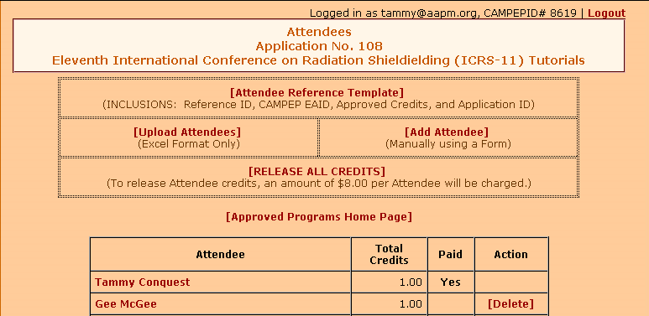

  - Notice that the credits have been paid/released for Tammy Conquest, but not for Gee McGee. Therefore, to release credits for Gee McGee, click on the [RELEASE ALL CREDITS] link located at the top of the page and the following screen will appear.
NOTE: Currently to release Attendee credits, an amount of $10.00 per Attendee will be charged.
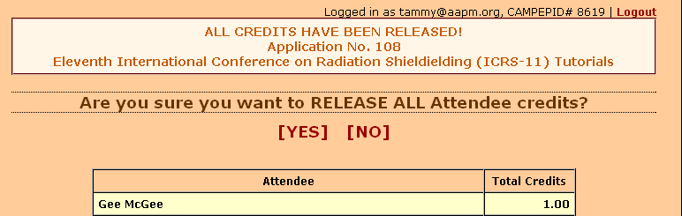

  - Click on the [YES] link to release the credit(s).
  - If [YES], the next step is the payment processing.
  - Once paid, you will be redirected to the “Attendees” home page. See screenshot below. Also, an email will be sent to each Attendee informing them that their credits have been released.

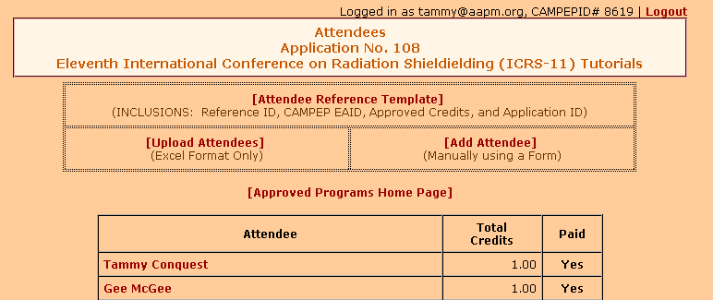

- Create an Update Application
  - If you would like to add an update to the original (parent) application, click on the link titled [Update] under the “Action” column under the Approved Programs tab.

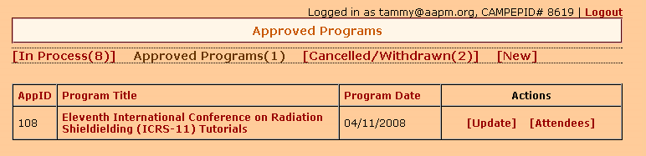

  - Follow the same instructional procedures for submitting a new application.

