Brian F. Loughery, PhD, DABR

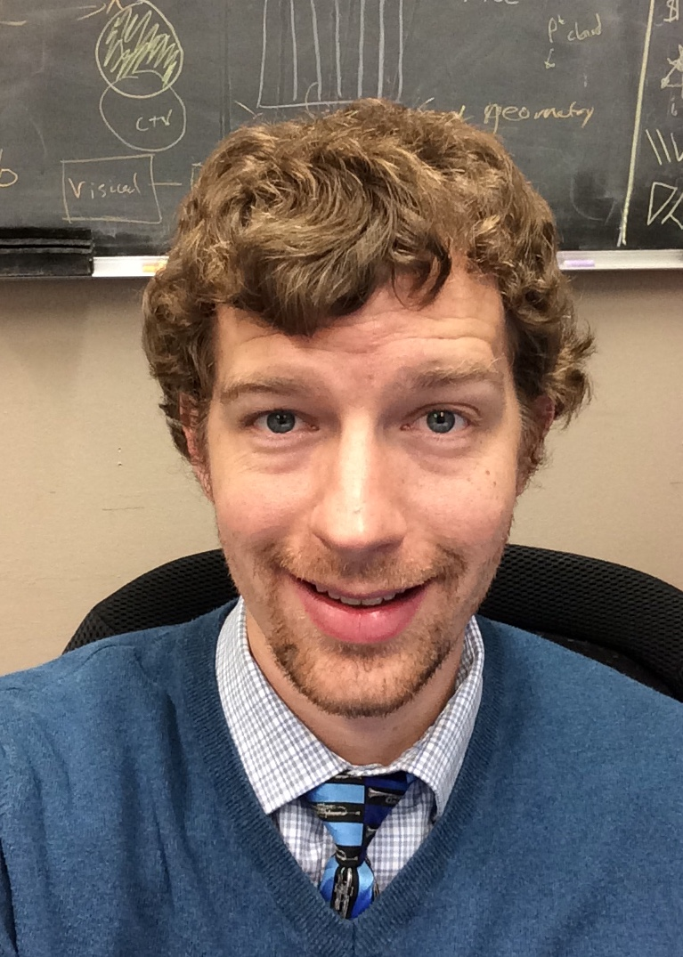

Brian Loughery earned an undergraduate physics degree from the University of Notre Dame in 2010, only learning about medical physics while applying to graduate programs. He obtained an MS from San Diego State University just as its radiological health physics program was being accredited by CAMPEP, graduating in 2012. He then enrolled at Wayne State University, where he received his doctorate in medical physics in 2018 while simultaneously completing a therapeutic physics residency at the Karmanos Cancer Institute in Detroit, MI.

Dr. Loughery was appointed to the faculty of Wayne State University in 2018 as an assistant professor of oncology with a clinical appointment at the Karmanos Cancer Institute, and earned ABR certification in therapeutic medical physics in 2019. In his short time at WSU he has established a clinical internship program for second-year graduate students, served on AAPM working groups for graduate program curriculum and the DMP, and is actively mentoring 2 undergraduate honors and 2 master’s thesis projects investigating augmented reality, output quality assurance automation, and off-axis Winston-Lutz testing. He has authored an article on medical physics residency placement and served a four-year term on the ABR initial certification committee. He teaches treatment planning and brachytherapy courses to second-year graduate students on the therapy physics track, along with a core introductory medical physics course for juniors and seniors in the Wayne State biomedical physics program. He is a proud contributor to the FocusStem NextGen program at Karmanos. Dr. Loughery has served on the CAMPEP Graduate Education Program Review Committee (GEPRC) since January, 2020.

